Wi-Fi (Solved Question)

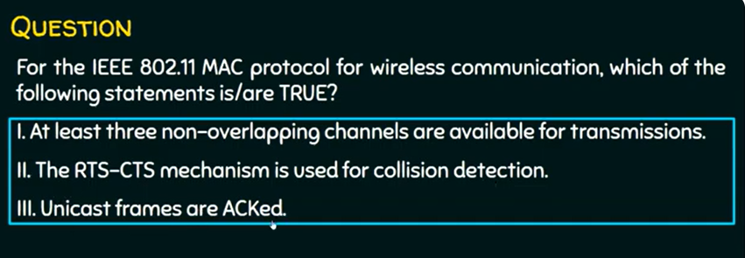

1 and 3 are true. 2 is false.

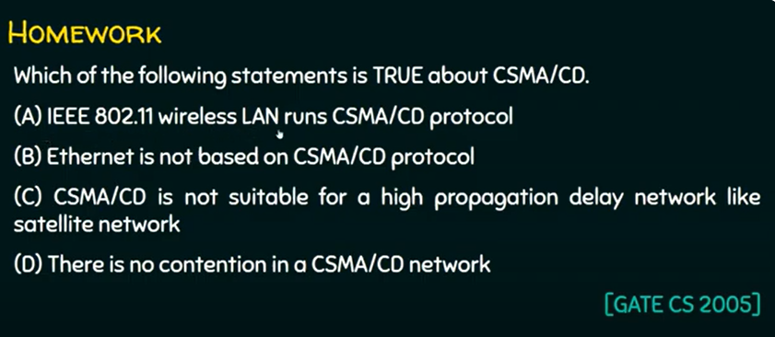

Answer: C